Sau khi viết repo thì qua service

Vẫn như repo Tạo 1 IService và service

I service thì copy bên Irepo và đổi tên là được

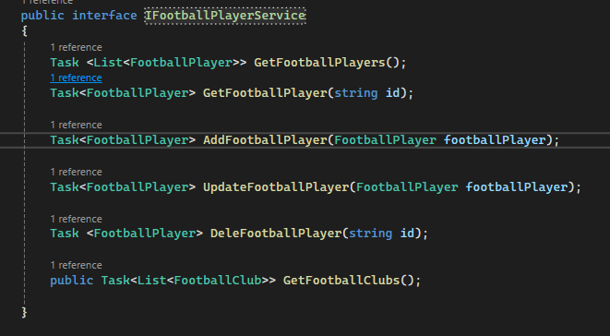

Sau đó bên service thì dependency injection

private readonly IFootballPlayerRepo _footballPlayerRepo;

public FootballPlayerService(IFootballPlayerRepo footballPlayerRepo)

{

_footballPlayerRepo = footballPlayerRepo;

}

public async Task<FootballPlayer> AddFootballPlayer(FootballPlayer footballPlayer)

{

return await _footballPlayerRepo.AddFootballPlayer(footballPlayer);

}

public async Task<FootballPlayer> DeleFootballPlayer(string id)

{

return await _footballPlayerRepo.DeleteFootballPlayer(id);

}

public async Task<List<FootballClub>> GetFootballClubs()

{

return await _footballPlayerRepo.GetFootballClubs();

}

public async Task<FootballPlayer> GetFootballPlayer(string id)

{

return await _footballPlayerRepo.GetFootballPlayer(id);

}

public async Task<List<FootballPlayer>> GetFootballPlayers()

{

return await _footballPlayerRepo.GetFootballPlayers();

}

public async Task<FootballPlayer> UpdateFootballPlayer(FootballPlayer footballPlayer)

{

return await _footballPlayerRepo.UpdateFootballPlayer(footballPlayer);

}

}